**CNSL Lab Assignment 14**

**Neeti Kurulkar**

**To study the IPsec (ESP and AH) protocol by capturing the packets using Wireshark tool.**

1. **Authentication Header (AH) in IPv4**

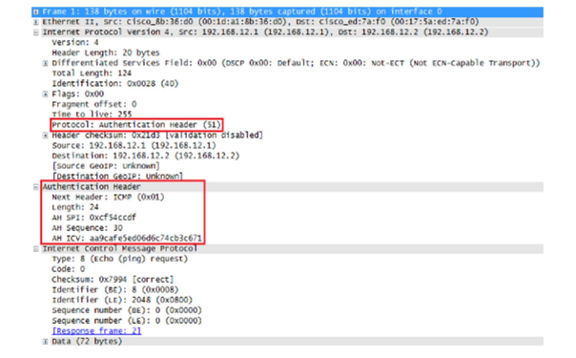

1. **Encapsulating Security Payload (ESP)**

